30.10.2013

Submission Report
Assignment 1 for Software Engineering Foundation F21SF

Student name: Marcin Paweł Kopacz
Person ID: H00176255
Course: Information Technology – Software Systems

- Introduction
Competition used in program is soapbox race where different teams create vehicles and try to impress judges and audience. As reference I used this:
http://soapbox.redbull.co.uk/teams

http://www.youtube.com/watch?v=9Hpgr9bgpuE
- Copetitors atribiutes:
-Id- Unique number 0-100 for each competitor
-Name- Names of teams consist with maximum 3 parts
-Marks- Judges marks for each team, 5 marks in range [0-5]
-Audience- Response of audience [0-100] %
-Level of Art- Measured in range 1-6

- Overall score calculation:
Overall = Averege of Marks*Audience

- This application meets the specification fully. Selection is made in console by Scanner.

GetFullDetails() and getShortDetails in my program are methods in CompetitorList class. Stage 2 and Stage 3 where a little misleading. I don’t know if localization of these methods would affect my grade.

Important. I did coding on Windows Machine and I was using “\r\n” for next line. Please run this program on Windows.

- Class diagram.
To create class diagram I used program Visual Paradigm with is free for noncommercial use.
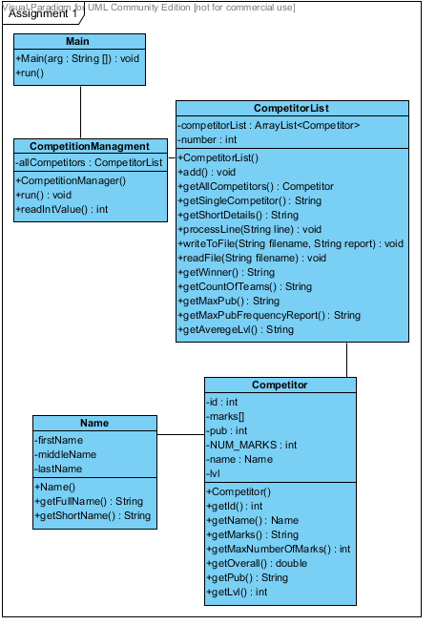
- Sequence diagram for method getShortDetails()
I use Visual Paradigm with very smart for this kind of task. But still a paint was used to export this.

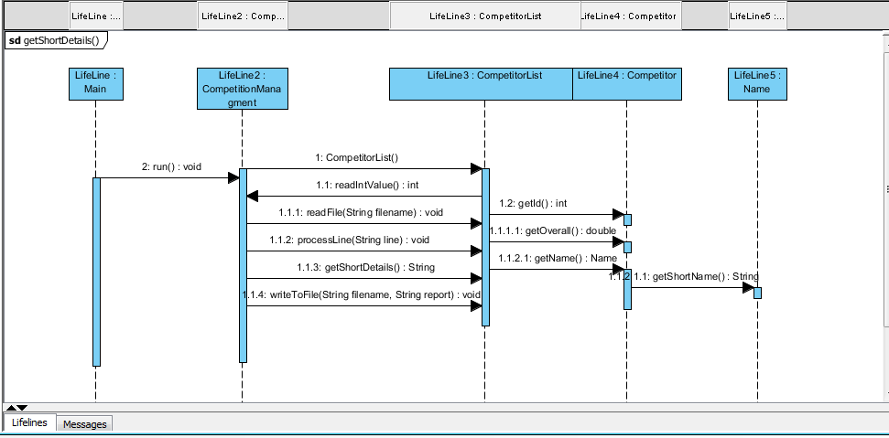

- Input and output files.
- List of competitors from DataInput.csv
0,Piece of Cake,3,3,4,5,4,70,1
1,Chariot of Fire,3,4,5,3,2,65,2
2,Here For Beer,2,3,3,4,4,60,5
3,The Regulators,4,4,3,4,4,80,5
4,The Bee Team,3,3,1,4,2,50,6
5,TheRun Away Bakers,4,3,3,4,1,65,5
6,The Downtown Destroyer,4,4,4,3,4,90,4
7,Spit-Phya,5,5,5,4,5,98,5
8,The Bath Mobile,4,2,4,3,3,100,5
9,The Coffin Dodgers,3,3,4,3,2,30,3
10,Fly High,3,4,2,1,1,60,5

- The report created by program. Word did some formatting on it.
Full raport of competitors.
Id Team name Marks from Judges Audience Responce % Overall Level
0 Piece of Cake 3 3 4 5 4 70 2,2 1
1 Chariot of Fire 3 4 5 3 2 65 1,8 2
2 Here For Beer 2 3 3 4 4 60 1,6 5
3 The Regulators 4 4 3 4 4 80 2,5 5
4 The Bee Team 3 3 1 4 2 50 1,1 6
5 TheRun Away Bakers 4 3 3 4 1 65 1,6 5
6 The Downtown Destroyer 4 4 4 3 4 90 2,9 4
7 Spit-Phya 5 5 5 4 5 98 3,9 5
8 The Bath Mobile 4 2 4 3 3 100 2,7 5
9 The Coffin Dodgers 3 3 4 3 2 30 0,8 3
10 Fly High 3 4 2 1 1 60 1,1 5

Full details for 6
Team name is The Downtown Destroyer.
Judges gives them following marks: 4 4 4 3 4
Audience responce was: 90%.
This would give them Overall Score: 2,9 Level artism: 4

Short details for 6
Id 6 (TDD) has overall score 2,9

Winner of Soapbox competition is:
Team name is Spit-Phya.
Judges gives them following marks: 5 5 5 4 5
Audience responce was: 98%.
This would give them Overall Score: 3,9 Level of art: 5

Total number of teams in this year competition is :11
Audience have highest respond of: 100
How offen given Level of Art was used
Level of Art 1 : 1
Level of Art 2 : 1
Level of Art 3 : 1
Level of Art 4 : 1
Level of Art 5 : 6
Level of Art 6 : 1

Averege Level of Art is: 4,0
Other files made by testing will be provided and also they are in project directory.

- Testing
- Table of limitations
Id | Problem | Effect
1 | Marks as string | Catch work, but because of wrong index Name class crush
2 | Marks with high numbers 100 and more | Can accept any integer value but it will provide unreasonable results
3 | Very long name | Can be longer name with more parts but method getShortDetails() will be affected and will not produce good results
4 | Audience response as string | Catch work well and skip bad competitor
5 | Level of Art with as char | Catch work but method frequency report crash program
6 | Very long competition list >100 | Program crush in method frequency report
7 | Id competitor s> 1000 | Program work normaly

- Table of tests. Id corresponds to file names in test directory.

Id | Test | Tested
1 | Marks are integers | Marks=[ 3,3,b,5,4,],
2 | Marks are between [0-5] | Marks=[ 3,3,100,1000,4,],
3 | Name have maximum 3 “parts” | 6,The Downtown Destroyer with big Stick
4 | Audience response should be int | 10,Fly High,3,4,2,1,1,6ala,5
5 | Level of Art need to be int | 0,Piece of Cake,3,3,4,5,4,70,b
6 | Competition list should be limited | More than 140 competitors by copy
7 | Id of competitors should be 0-100
  100,Piece of Cake,3,3,4,5,4,70,1
  2222,Chariot of Fire,3,4,5,3,2,65,2

- Javadoc style comments for CompetitionList
It is attached form this page from separate document. Also in my project you can find pdf file with javadoc.

